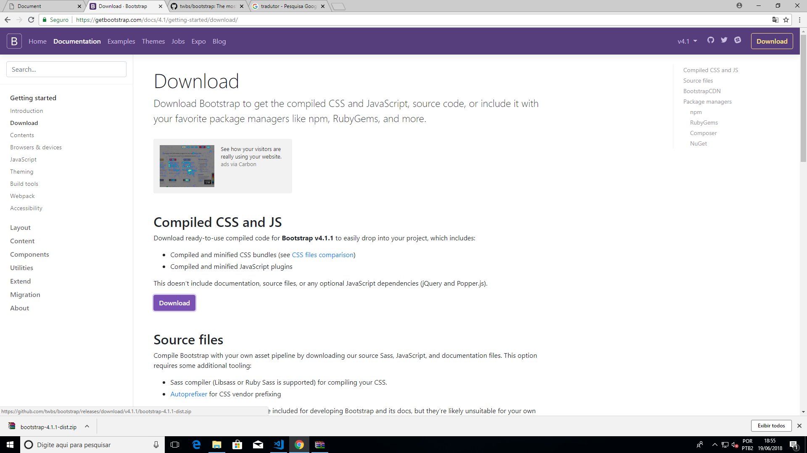

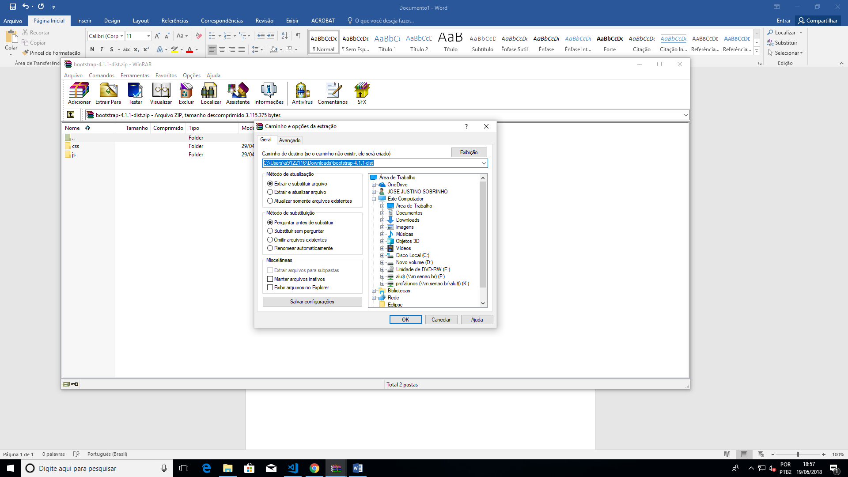

Many of our components require the use of JavaScript to function. Specifically, they require [jQuery](https://jquery.com/), [Popper.js](https://popper.js.org/), and our own JavaScript plugins. Place the following <script>s near the end of your pages, right before the closing </body> tag, to enable them. jQuery must come first, then Popper.js, and then our JavaScript plugins.

We use [jQuery’s slim build](https://blog.jquery.com/2016/06/09/jquery-3-0-final-released/), but the full version is also supported.

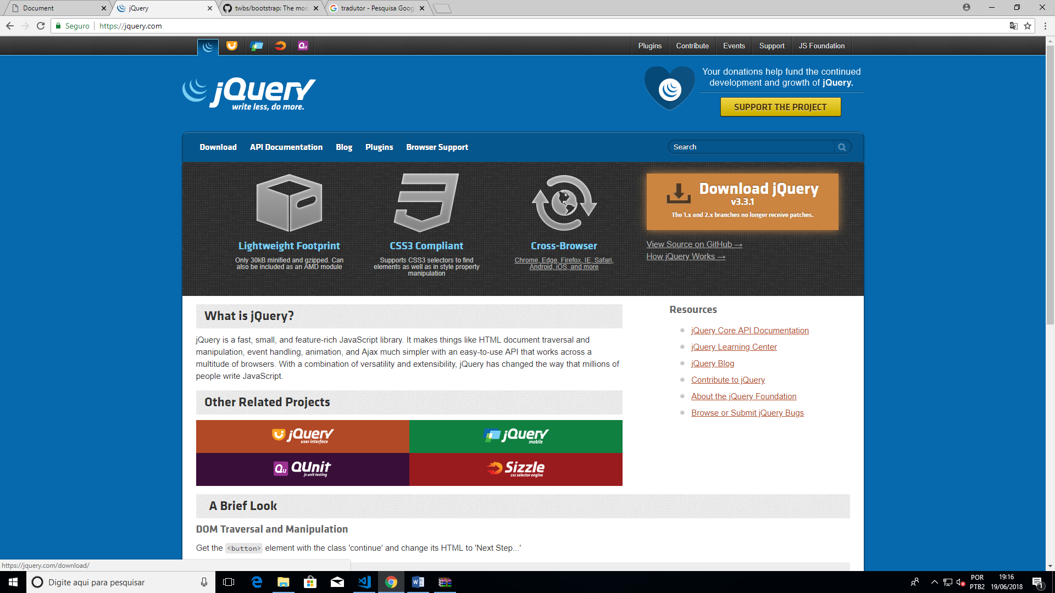

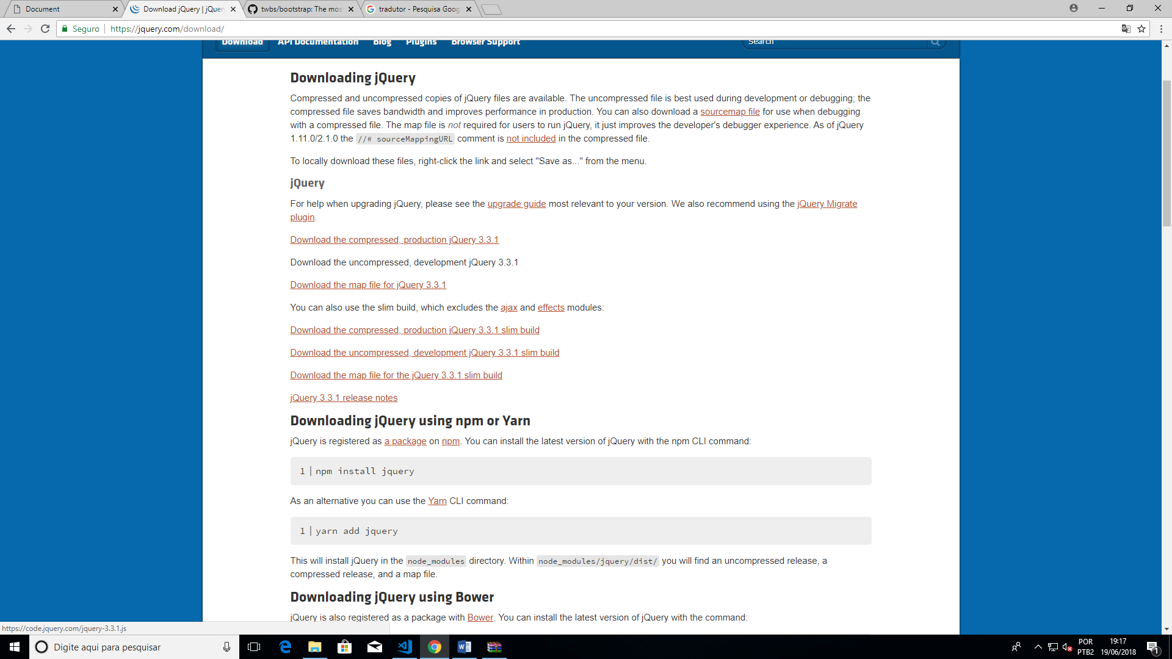

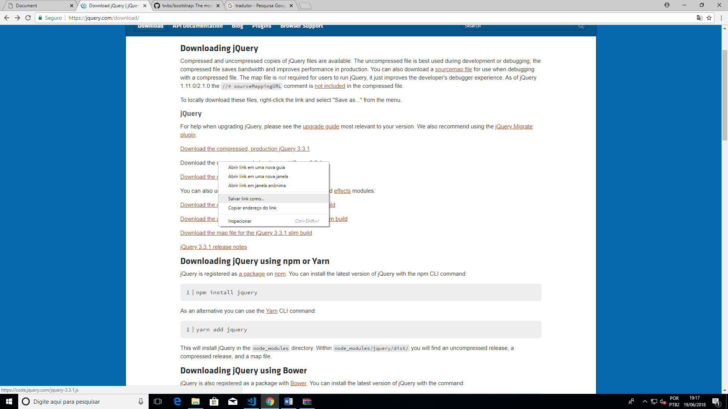

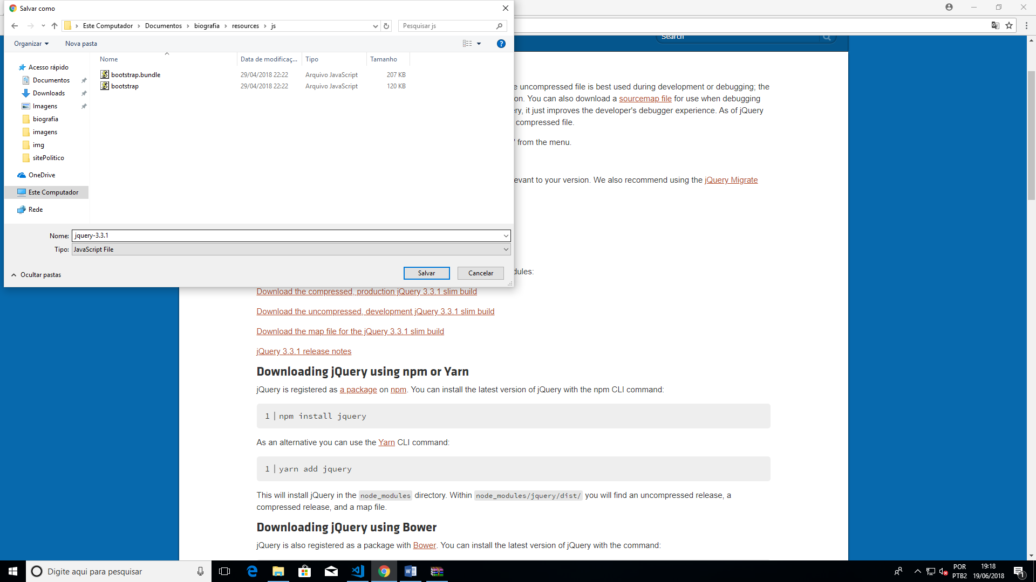

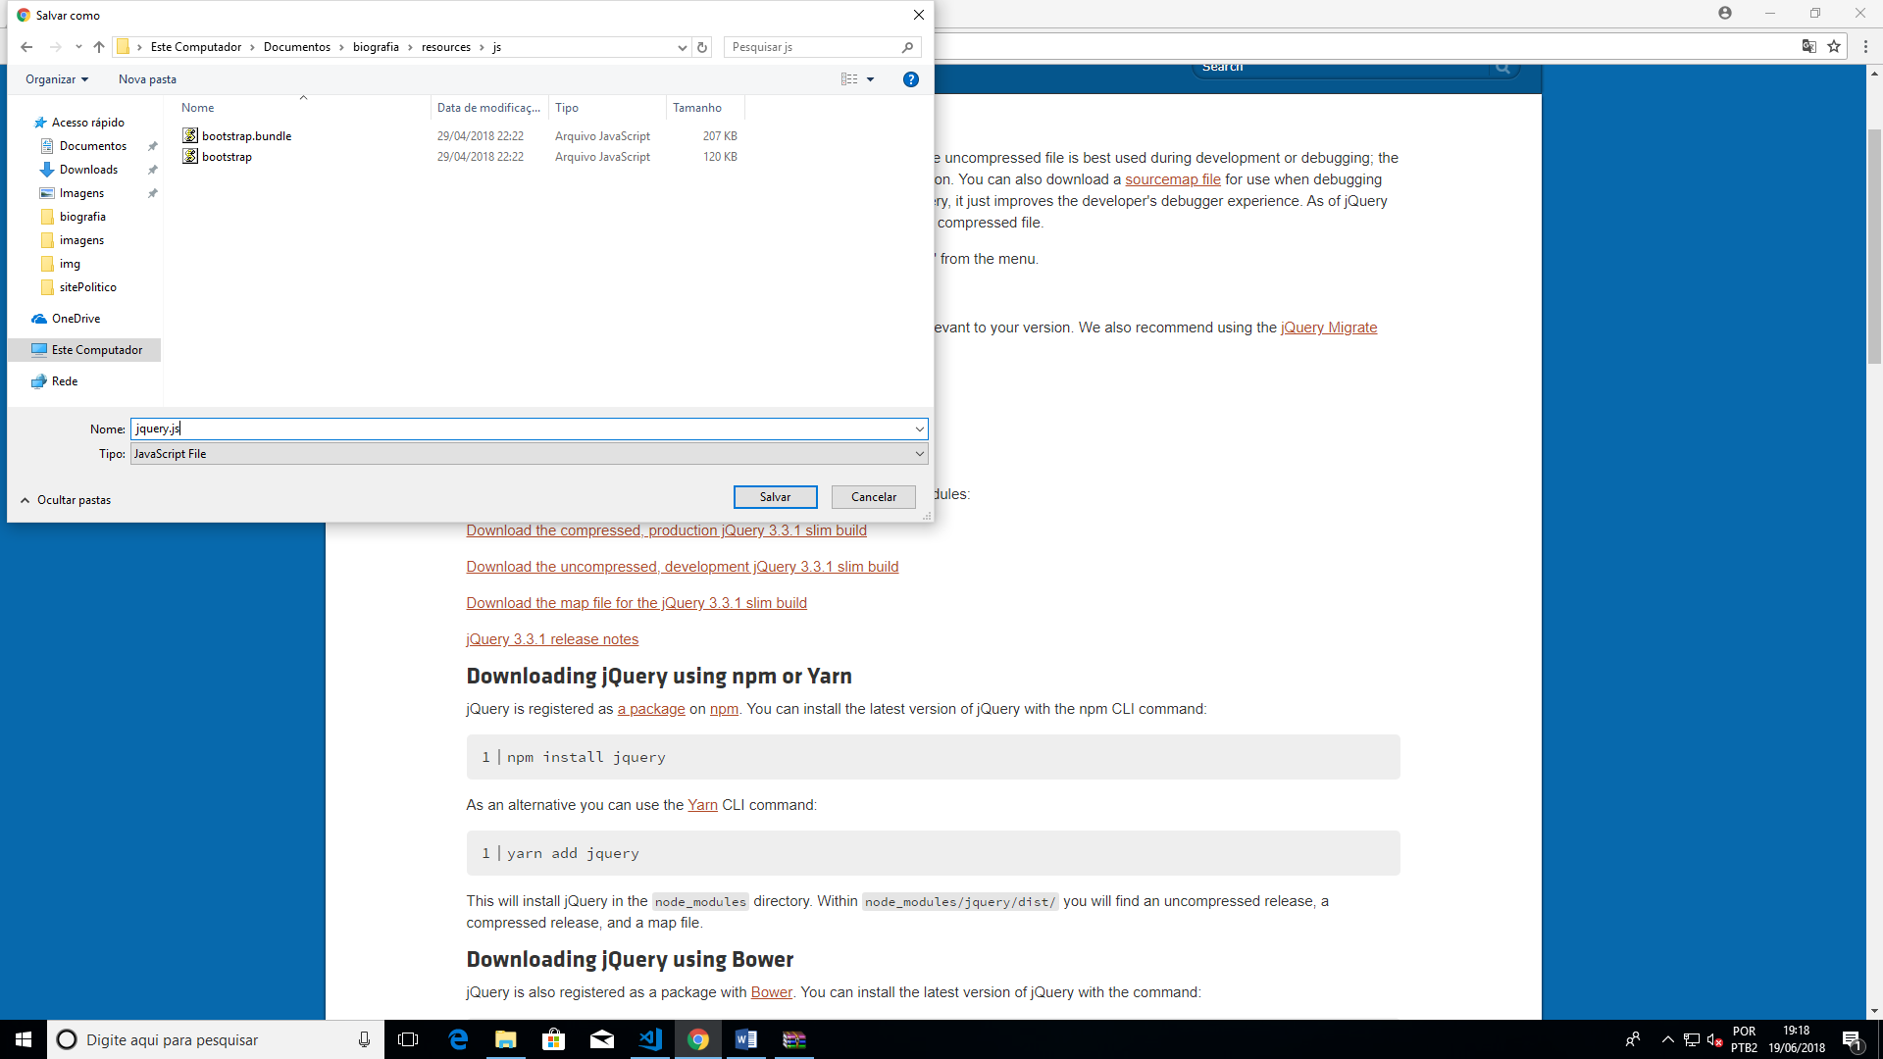

Agora o popper

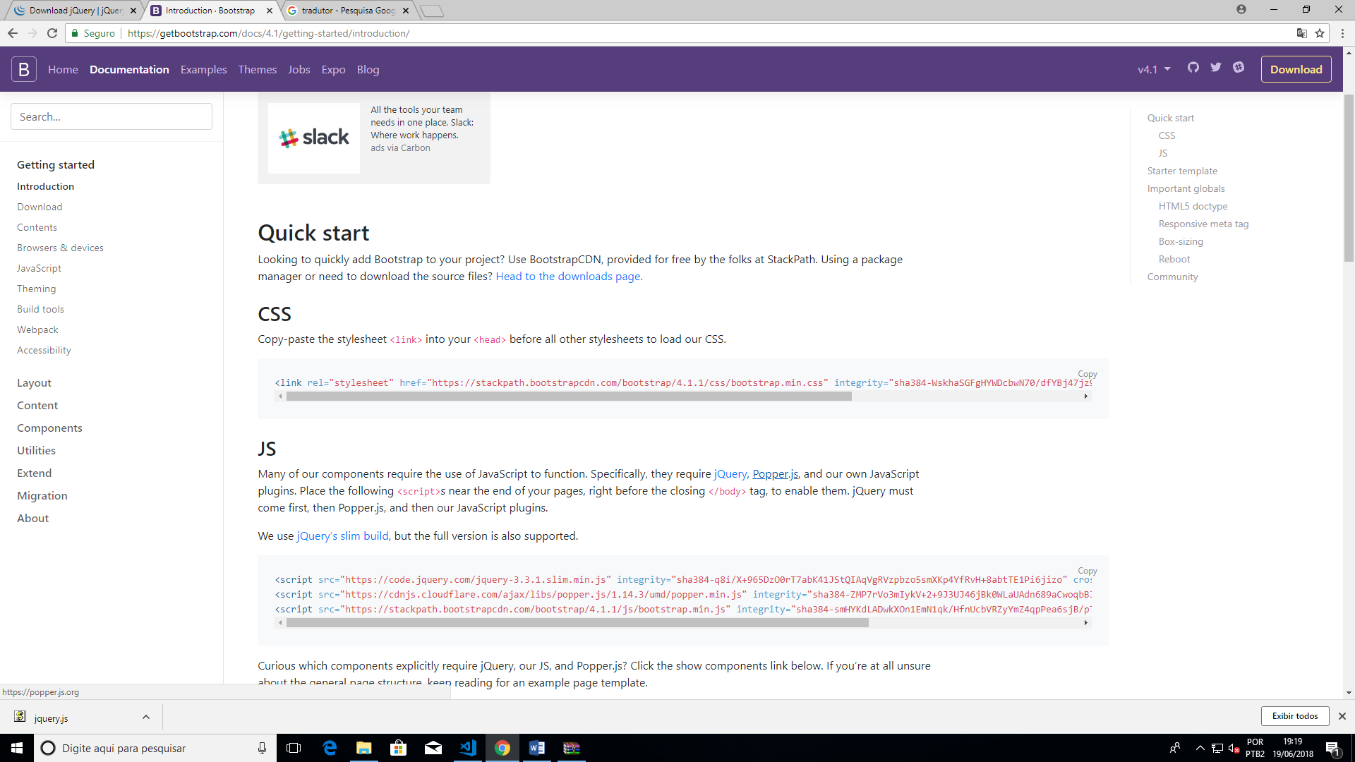

Ajeitar a div ALT + SHIFT + F

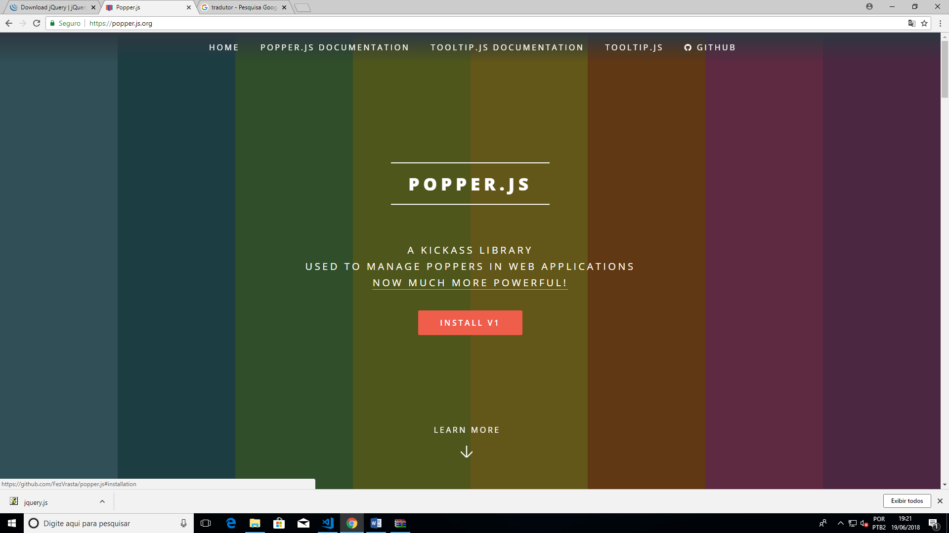

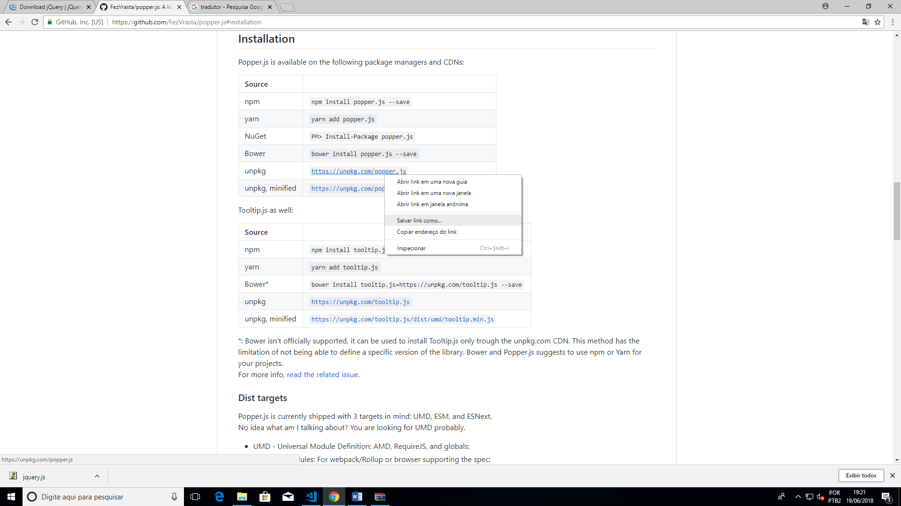

Classe container aproveita parte da tela e container-fluid aproveita toda a tela

